Swarm – Group Project. – Layering Light// put a ring on it

|  |  |  |
| --- | --- | --- |
|  | Thoughts | Thought by Jieming Hu |
| What's the Aim? | Installation art.  Functions of Light | virtual reality  visual art |
| What's the Context? (why are we doing it) | Site Specific For the Moma? Or brand new space that can be built inside/outside of existing gallery | 1. astronomy museum 2. Cultural Museum |
| What's the Point? | Experience/Perception & Floating in Space | Experience Perception |
| What's the medium? | Swarm system to build sculpture  3D quality of light  Smoke Machines  Room | multidimensional movie |
| What makes this only possible through Swarm | Generating a physical form that would otherwise be unattainable  Generating light patterns that have unique properties exclusive to Swarms | 1. Using swarm to generate many stars with different size and oribit. 2. Using swarm to simulate firework view |
| How | Generate a swarm  Constrain the Vectors Within an Ellipse  Save frames of swarm  Print frames as 3D | 1. Generate a swarm Programs to simulate the movement track of star 2. Generate a swarm Programs to simulate firework view |
|  |  |  |

1. HACK/ADAPT/MOD
2. REPRESENT/VISUALISE/MANIFESTATION
3. APPLICATION/OUTCOME/CONTEXT

**Notes:**

Room black

Lines Moves around

Possibility of language of slice type forms vs A random series of 2D objects?

Relationship of time?

Quality of Light through Laser cutting:

<http://www.journal-du-design.fr/design/les-baleines-en-bois-lumineuses-et-sculpturales-deduard-golikov-77318/>

Glass mirrors moving through

<https://www.youtube.com/watch?v=f6ra024-ASY>

––––

**Research/references by AM:**

* Nick Dong *Cosmic Dance – Gravity,* 2015 (breathing surface, floating cube, light, mirrors)  
  <https://www.studiodong.com/cosmic-dance>   
  <https://vimeo.com/136173495>
* Anthony McCall *You and I Horizontal*, 2005 (laser shapes through smoke machines in dark room)  
  <https://www.youtube.com/watch?v=HgzcbQlwT6w><http://www.anthonymccall.com/exhibitions.html>   
  <https://www.mca.com.au/collection/exhibition/706-light-show/>
* Olafur Eliasson *The Weather Project,* 2003 (the sun at Tate)  
  <http://www.tate.org.uk/context-comment/articles/the-weather-project>
* Conrad Shawcross *Slow Arc Inside a Cube IV*, 2009 (moving robotic arm with light inside cut out cube)  
  <https://www.youtube.com/watch?v=zur-A_EKG6A>   
  <https://www.mca.com.au/collection/exhibition/706-light-show/>
* James Turrell – all his work, or more specifically Ganzfeld  
  <http://jamesturrell.com/work/type/ganzfeld/>   
  <https://nga.gov.au/JamesTurrell/>
* Felix Golzalez-Torres *Untitled (Golden)* 1995 (golden bead curtain that people walk through)  
  <https://www.guggenheim.org/artwork/22508>
* teamLab Flo*wers and People – Gold,* 2015 (currently on display at the Art Gallery of NSW – interactive work)  
  <https://www.artgallery.nsw.gov.au/exhibitions/time-light-japan/>   
  <https://www.youtube.com/watch?v=BV_58t_ERZg>
* Nervous System generative lamp  
  <https://n-e-r-v-o-u-s.com/shop/search_tags.php?search=lighting>
* Troika Cloud, London, Heathrow airport  
  <https://www.youtube.com/watch?v=1lPy7cwhr_w>
* How do boids work <https://www.youtube.com/watch?v=QbUPfMXXQIY>
* 6.8: Combining Steering Behaviors: Flocking - The Nature of Code <https://www.youtube.com/watch?v=IoKfQrlQ7rA>
* John Baldesarri *Throwing 3 balls in the air to get a straight line (Best of Thirty-Six Attempts)* (1973) (book, random movements, seemingly arbitary goal, beautiful artwork)  
  <http://www.mocp.org/detail.php?type=related&kv=3219&t=people>

––––

Force Pulling them in Centrally

A Vector Position in the Center

Align/cohere/avoid magnet behavior (Frosted quality of Light)

Agents Grow with time

Box installation <https://www.youtube.com/watch?v=lX6JcybgDFo>

SVG reference: <http://svgjs.com/manipulating/#positioning>

**Research work by (Jieming Hu):**

**Code part :**

1. <http://alpha.editor.p5js.org/Jieming/sketches/BJnegdQRx>

Swarm project: Original work by Henry Fritz

Adapted by Jieming Hu

1. <http://alpha.editor.p5js.org/Jieming/sketches/ByInxOX0e>

Swarm project: Original work by Henry Fritz

Adapted by Jieming Hu (add comments)

**visual art：**

1. Swirling clay on kickwheel by Mikhail SADOVNIKOV   
   <https://www.youtube.com/watch?v=jWAa7EigJRs&t=5s>
2. "The Splendor of Color Kaleidoscope"  
   <https://www.youtube.com/watch?v=q2fIWB8o-bs>
3. "The Most Amazing Space Nebulas"  
   <https://www.youtube.com/watch?v=nY4uOZrzv0s>
4. (Distorting Space and Time | United Visual Artists' Momentum)  
   <https://www.youtube.com/watch?v=mPNbH4gRqFM>
5. <https://www.youtube.com/watch?v=zoFK_WWII1c&list=PLkubNZ4GyjCNott9cPnpRSD_p0XRqeF6F>
6. <https://www.youtube.com/watch?v=UZw5Y3XcGIw&list=PLkubNZ4GyjCNott9cPnpRSD_p0XRqeF6F&index=2>
7. <https://www.youtube.com/watch?v=6mTeFW6p9fE&index=4&list=PLkubNZ4GyjCNott9cPnpRSD_p0XRqeF6F>
8. <https://www.youtube.com/watch?v=XNWhN4Bmjyg&list=PLkubNZ4GyjCNott9cPnpRSD_p0XRqeF6F&index=9>
9. <https://www.youtube.com/watch?v=0HzIJjoWaBc&index=16&list=PLkubNZ4GyjCNott9cPnpRSD_p0XRqeF6F>
10. <https://www.youtube.com/watch?v=YZ3cn7ptCkw&index=18&list=PLkubNZ4GyjCNott9cPnpRSD_p0XRqeF6F>

Reference:

1. "Amazing Art Video". YouTube. N.p., 2017. Web. 10 May 2017.
2. N.p., 2017. Web. 10 May 2017.
3. "Relax Music - The Most Amazing Space Nebulas - 2 Hours - Sleep Meditation - 1080P HD". YouTube. N.p., 2017. Web. 10 May 2017.
4. "Mystic Move, 2016 (Audio By Tipper)". YouTube. N.p., 2017. Web. 10 May 2017.
5. "Relax Music - The Most Amazing Space Nebulas - 2 Hours - Sleep Meditation - 1080P HD". YouTube. N.p., 2017. Web. 10 May 2017.
6. "The Splendor Of Color Kaleidoscope Video V1.1 1080P". YouTube. N.p., 2017. Web. 10 May 2017.
7. "Undercroft Live Visual Show, Stallbastei Graz, 16.9.16". YouTube. N.p., 2017. Web. 10 May 2017.

**Finished the draft sketch (Jieming)**

**Code processing:** <http://alpha.editor.p5js.org/Jieming/sketches/BJeBd7w1Z>

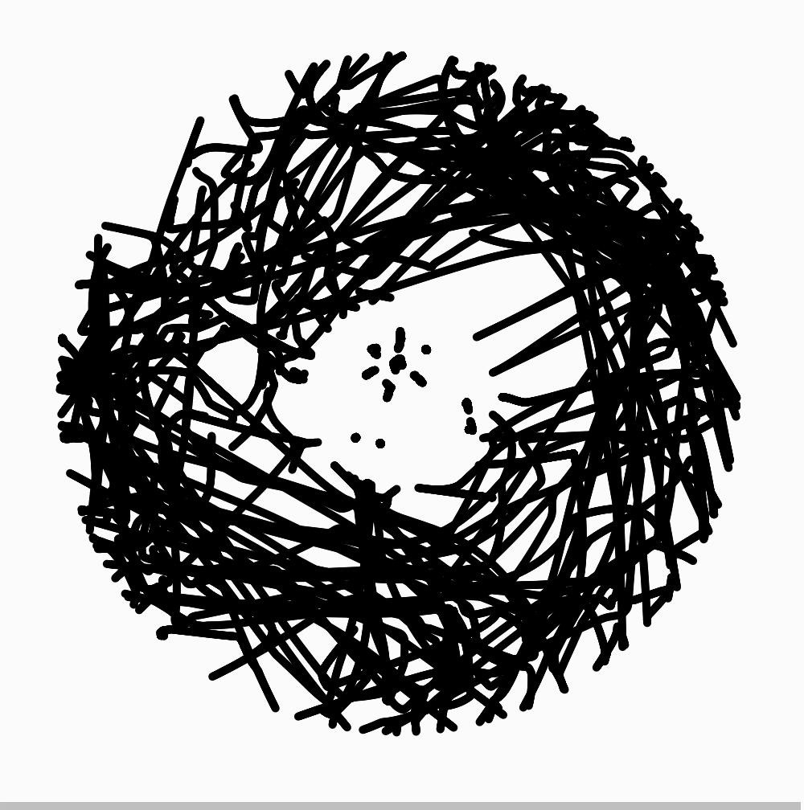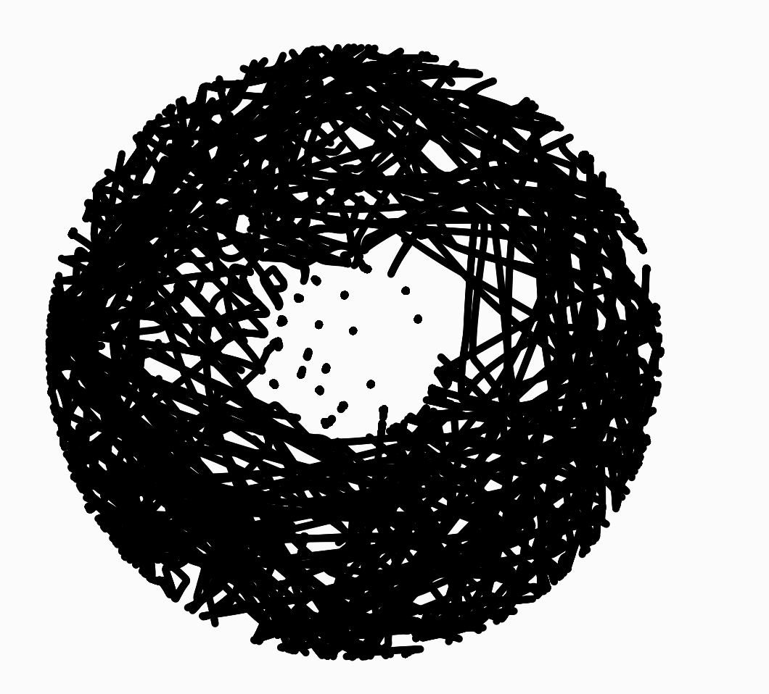

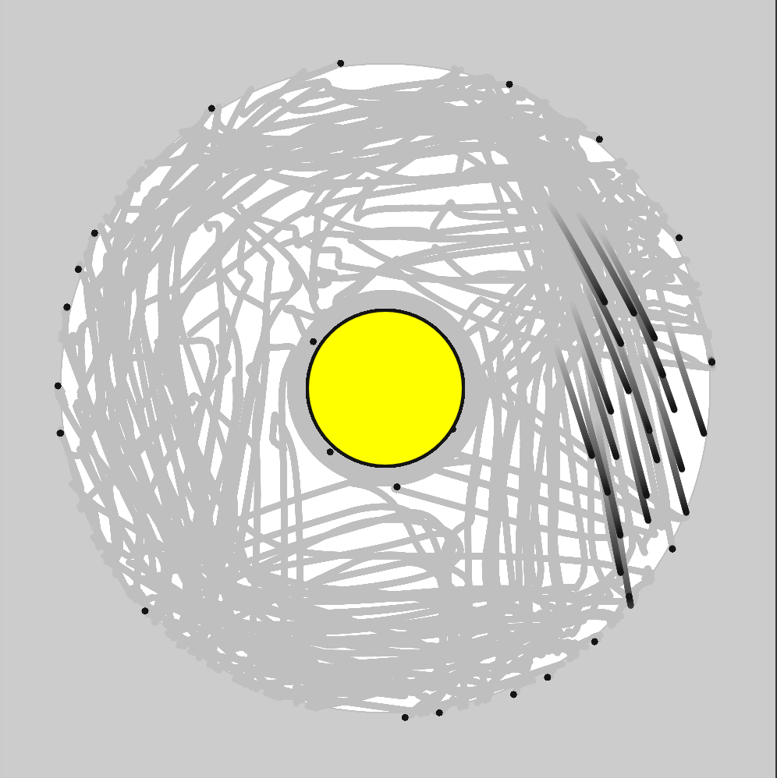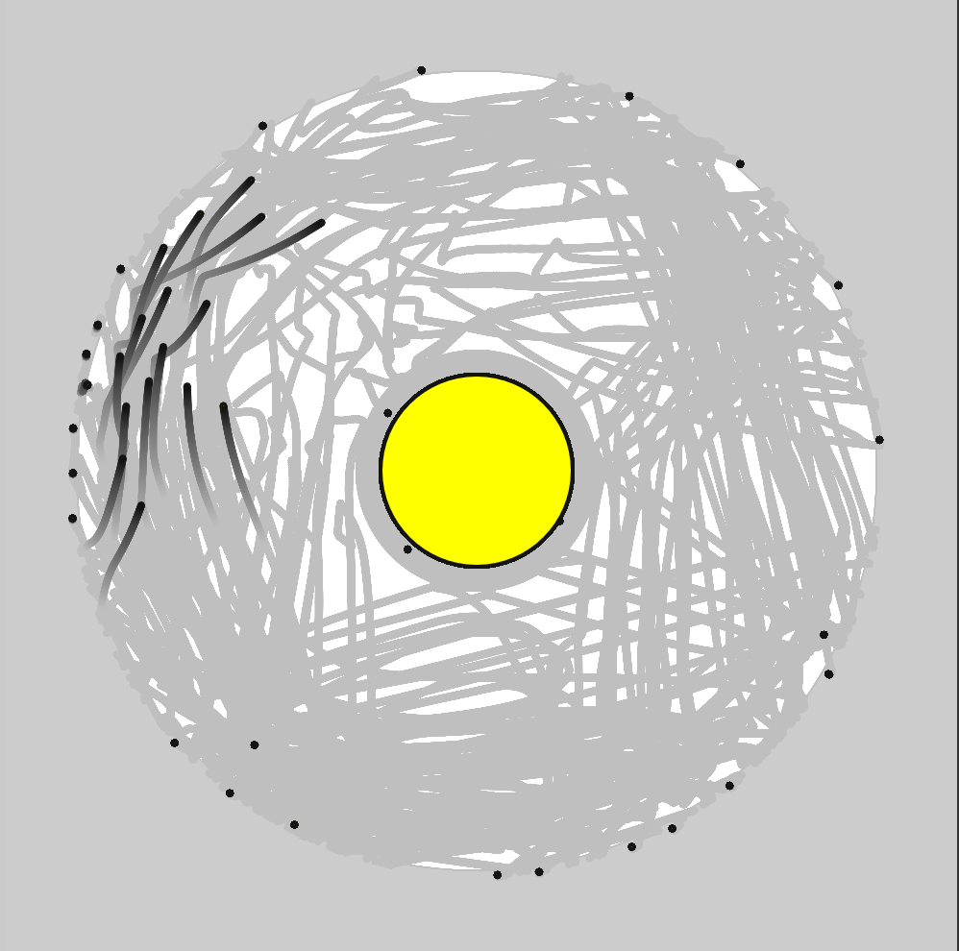

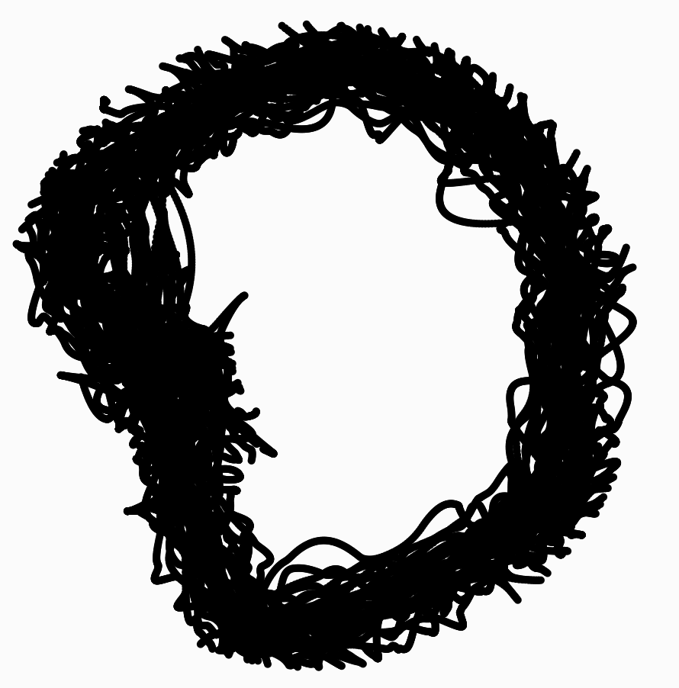

Ideal work:

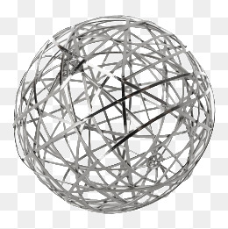

MDF: 9mm board = 2400 x 1200 sheet

300 x 300mm circle x 9mm depth (model)

2400 / 300 = 8 (less for gap) = 7

1200 / 300 = 4 (less for gap) = 3

3 x 7 = 21 circles per board

= 2 x MDF board

–––

Andy's swarm donuts:  
<http://alpha.editor.p5js.org/andy.mullens/sketches/HJumdj0yZ>

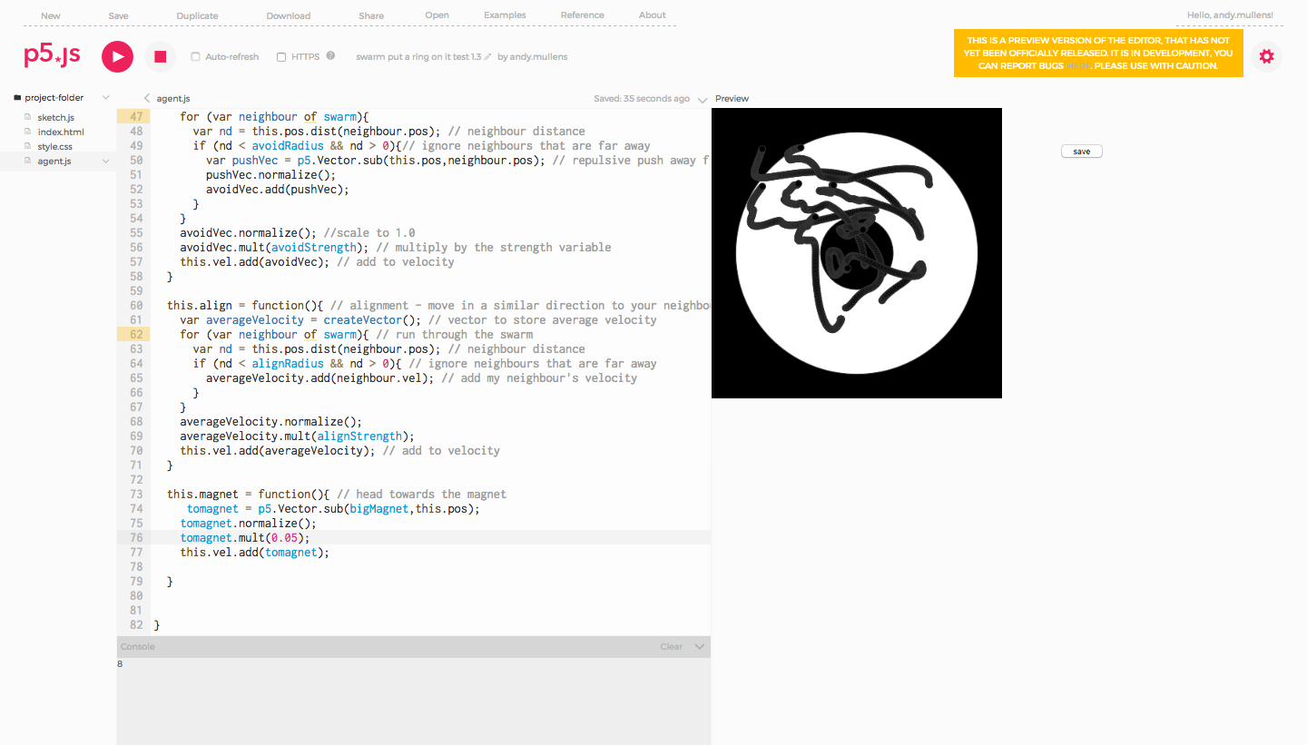

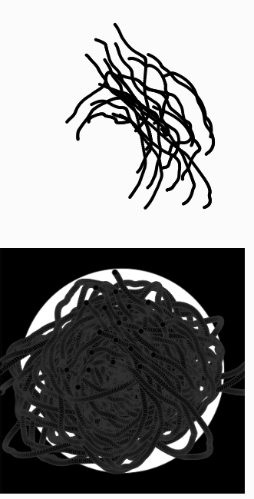

Later version: <http://alpha.editor.p5js.org/andy.mullens/sketches/SkQz-l_gW>

Save as svg: <http://alpha.editor.p5js.org/Jieming/sketches/r1ubJB_gb>

Background for new form

Perspex can be purchased from Plastic Creations in Fyshwick:

<http://www.plasticcreations.com.au/> (I bought all my perspex from Honours from here)

––––

Pats Rendition of the Swarm: Magnets + Repulsion Systems



http://alpha.editor.p5js.org/pat_rose/sketches/Hy4mlJdgW

Andy to do:

* Start powerpoint presentation
* Start writing presentation
* Start forming report with references <http://soa.anu.edu.au/study-protocols/referencing-guidelines>

Super duper rough but this might help in defining the project:

Swarm Group Project Title  
Layering Light  
A Millennial Moment  
Put a Ring on it.

In a world obsessed with being social as a media we never have a chance to escape the hustle that is millennial life. Defined by our clothes, our wealth and our need to feel love and accepted; we as a generation are in that search for a hit of dopamine in the form of a message tone. Insert title here teaches us value the moment and to value the people around us.

On a conceptual level, we aim to use p5.js to create an installation piece dedicated to its own internal space working within a gallery such as the Mona. The installation is a piece based upon human experience where three core elements are broken down to lead the audience to an understanding of self. These three elements are environment, objectivity and light. For the Assignment 2 Swarm project, we’ll focus upon “the object” but we still aim to define its environment.

The object itself could be best described as sculptural in nature. Defined by a magnetic sense of gravity, the object is sculpted from laser cut planes, that are a physical expression of frozen time. A result of programming magnetism the object is punctured by the swarm, cracked and skewed. On a metaphorical level the glossy perfection of the form has been torn away by the light within.

~~The Light is defined by the people. The light would be controlled by the people as they enter and leave through the piece they would be counted becoming the input for p5.js controlling the quality, nature and behavior of the light within the space, the gathering of this human swarm would result in a warm and beautiful intensity. As they leave and as the space is left hollow and empty the light loses its flicker resulting in darkness.~~

The space itself would be a reflection of the object. Where negative is positive, positive space would become negative, creating a hollow to be inhabited. The duality of the object and the space is in itself a representation of our generation. An understanding that something that makes you feel fulfilled can also leave you feeling empty and without cause, if there is no one there with you.

Exporting SVG

Saving The Time Series - how do we determine which frames are saved? (Kernal Sanders)  
What are the forms and why

As Vector Shapes

Trails, Tails etc... Polygons perhaps,

Play visual

Decide on Scale

-tech + vis: what does this internal volume look like? Elliptical voids? Spatial quality? Then how do we make our system draw this?

Today: make system that generates form, how to get to SVG part

Generating Forms from PNG VS SVG

FOR GROUP MEETING ON SATURDAY 10AM __ ANDY LIVES AT:

17 Wattle Street O'Connor ACT 2602

**Documentation explaining the code and generative processes used:**

In the agent.js:

1. Created function Agent(xpos, ypos, xvel, yvel) to define the attribute of each agent
2. Created this.draw = function() to define what we want to draw in the canvas
3. Created this.move = function() to define movement of each agent
4. Use this.avoid = function() to make sure each of agent cannot get too close to their neighbors
5. Created this.align = function() to make sure all of agents will move in a similar direction so that they will not crash with each other
6. Created this.repulsion=function() to make sure they cannot move out of the circle margin and move in the center circle
7. Use this.cohere = function() to define they will move towards the middle with their close neighbors
8. Use this.magnet = function() and this.antimagnet = function() to make them head towards the magnet

In the sketch.js:

1. Define all of variables that we need to use in the class, such as swarm numbers and friction
2. Use function setup() to define the size of canvas, three ellipses' location and iteration to create agent objects
3. Use function draw() and for loop to iteration call functions which we create in agent.js
4. Use function saveSVG() to implement SVG save function